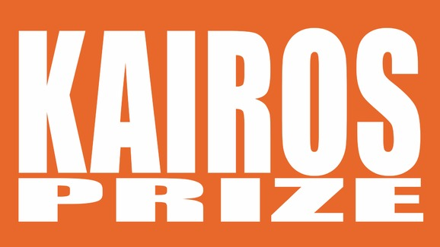
Beginning Screenwriters Vie for $15,000 Prize

Movieguide® is pleased to announce that its 12th Annual Kairos Prizes for Spiritually Uplifting Screenplays is now open for submissions.

The contest is unique in that it has a category specifically for beginning, or first-time screenwriters with a $15,000 cash prize. In addition to the Kairos Prize for Beginning Screenwriters, there is the Kairos Pro category, for established or professional screenwriters. Kairos Pro also has a $15,000 cash prize.

Additionally, the winners of the Kairos Prize’s get their screenplays into the hands of top studio executives and production houses looking to purchase inspiring scripts. Scripts that have found success through the Kairos Prize includes Sony Picture Entertainment’s ALL SAINTS, which released nationwide last month. Other studios that have picked up Kairos Prize winners include Pure Flix Entertainment and Fathom Events.

Movieguide® is also thrilled to announce that this year’s Kairos Prizes are sponsored by The Timothy Plan, a family of faith-based mutual funds offering individuals to invest with biblical principles.

The deadline to submit your script is October 31, 2017, so don’t wait any longer.

The winners of the two Kairos Prizes will be announced at the 26th Annual Movieguide® Faith & Values Awards Friday, February 2, 2018 in Los Angeles, Calif. For more information on the Kairos Prize, click here, or go to www.kairosprize.com.

